Attendance, Exam, and Assignment Adjustment (AEAA)
OPTION 2: SAS & Faculty Coordinated AEAA Guide (Updated July 2026)
Please read this guide in its entirety. AEAA follows a specific process, and all required steps must be completed before you can use this accommodation.
The AEAA accommodation is most effective when requested at the beginning of every semester and before any attendance issues, missed exams, or missed assignments occur. AEAA is not retroactive and cannot be applied until your AEAA Plan has been finalized.
What is AEAA – SAS & Faculty Coordinated?
Students approved for AEAA are initially given eligibility in Knight’s Access for AEAA – Student & Faculty Coordinated, which allows students to work directly with their instructors to develop an AEAA Plan.
- If you wish to pursue this option, please view our OPTION 1: Student & Faculty Coordinated AEAA Guide by visiting this link:
Students who prefer SAS to coordinate this process may instead choose AEAA – SAS & Faculty Coordinated. With this option, SAS works directly with your instructor to develop your AEAA Plan on your behalf.
- If you wish to pursue this option, please view the instructions below.
I want to... | Choose...
Work with my instructor on my own to create AEAA Plans each semester. I understand that I must contact my professor to begin this process. | AEAA – Student & Faculty Coordinated
Have SAS work with my instructors to create AEAA Plans in some of my courses this semester AND have the choice to work with my instructor on my own | AEAA – SAS & Faculty Coordinated (Semester-by-Semester Method)
Only have SAS work with my instructors to create my AEAA Plan for all courses. I do not ever want to create plans with my instructors on my own. | AEAA – SAS & Faculty Coordinated  (Permanent Eligibility Method)
Which Option is Best for Me? (AEAA Quick Decision Guide)

There are two ways to use AEAA – SAS & Faculty Coordinated, and both options require student interaction to be activated every semester. Below you will find information about how to activate this accommodation with your preferred method.
1. Choose How You Want SAS to Coordinate Your AEAA Plans
Semester-by-Semester Method
Choose this option if you would like SAS to coordinate AEAA for selected courses during a particular semester. This option will allow you to:
- Decide which courses you would like SAS to coordinate each semester.
- Choose a combination of Student & Faculty Coordinated and SAS & Faculty Coordinated options for your courses for the current semester (Optional)
Semester-by-Semester Method Activation Steps:
- Complete the AEAA (SAS & Faculty Coordinated) Survey Form
  - On the survey, indicate only the course(s) for which you would like SAS to coordinate your AEAA Plans.
*OR*
Permanent Eligibility Method
Choose this option if you prefer AEAA – SAS & Faculty Coordinated to become a permanent, requestable AEAA accommodation in Knights Access.
Permanent Eligibility Method Activation Steps:
- Complete the AEAA (SAS & Faculty Coordinated) Survey Form one final time.
- On the last question of the survey, select the Permanent Eligibility option labeled “Add AEAA (SAS and Faculty Coordinated” as my only AEAA option for ALL of my classes and remove the AEAA (Student and Faculty Coordinated) option.
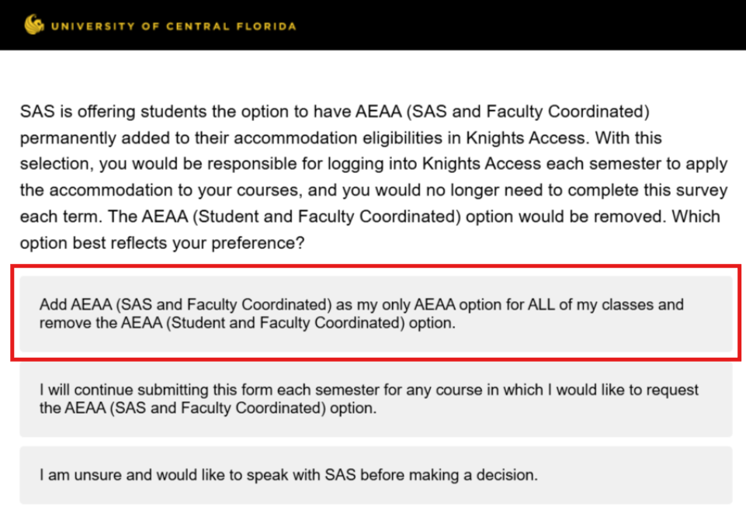 Figure One: Screenshot of AEAA SAS & Faculty Course Request Form’s last question with a red rectangle outlining the first survey response
After your Permanent Eligibility request is received and processed, SAS will:
- Remove AEAA – Student & Faculty Coordinated from your accommodation eligibilities.
- Add AEAA – SAS & Faculty Coordinated as your requestable AEAA accommodation in Knights Access.
2. Request Your Accommodations in Knight’s Access
Semester-by-Semester Method
If you do not have any other approved academic accommodations: Go to Step 3.
If you have approved accommodations other than AEAA (For example: 1.5x extended time on exams and quizzes):
- Log-in to the Knights Access Portal and activate your requests for the current semester by submitting your Course Accessibility Letter(s).
  - Instructions for submitting Course Accessibility Letter(s)
After completing the Qualtrics Survey, SAS will manually add AEAA – SAS & Faculty Coordinated for the specific course(s) you indicated for that semester and resend your Course Accessibility Letter(s) to your instructor(s).
*OR*
Permanent Eligibility Method
After you have gone through the process above and SAS has added AEAA – SAS & Faculty Coordinated as a permanent accommodation, during the following semesters you must:
- Log-in to the Knights Access Portal and activate your accommodation request(s) for the current semester.
  - Instructions for submitting Course Accessibility Letter(s)
  - If you are approved for other accommodations, then you must request all desired accommodations for each course to activate them each semester.
Once you request AEAA – SAS & Faculty Coordinated:
- Your Course Accessibility Letter will be sent to your instructor within 1 business day.
- SAS will automatically begin coordinating your AEAA Plan.
- No additional AEAA Semester-by-Semester Request Form needs to be submitted.
IMPORTANT: Remember, even with the Permanent Eligibility Method, you must request the AEAA accommodation every semester for each course where you would like to use AEAA.

3. AEAA Flex Plan Development (Applies to Both Methods)
Once the AEAA Flex Plan process has started, SAS and your instructor will work together to develop a plan for your course.
AEAA – SAS & Faculty Coordinated Process After Activation
- Your instructor will receive a notification to complete your AEAA Plan.
- Instructors typically have 7–10 calendar days to complete the plan.
- If an AEAA Plan is not submitted within that timeframe, the SAS default Flex Plan will be applied.
- SAS will review the completed plan to ensure it is reasonable and finalized.
- You will receive an email to your UCF email address when your AEAA Plan is ready.
You can review your completed AEAA Plans at any time by logging into Knights Access and selecting the Flex Plan module.
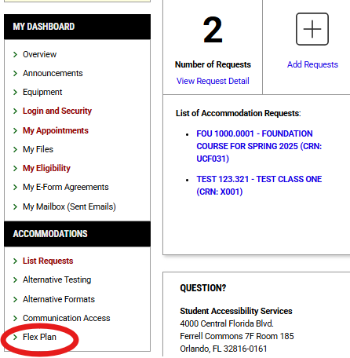
Figure Two: Screenshot of Knight's Access Dashboard with red circle around the "Flex Plan" button on the left side of the screen.

Important Reminders & Expectations for Using AEAA
- AEAA is not automatically activated each semester. You must request the accommodation every semester for each course where you wish to use it.
- If AEAA is initiated after a course has already begun, any flexibility provided will be based on what is reasonable within the context of the remaining course requirements.
- AEAA is not retroactive (meaning it does not apply to absences, assignments, exams, or deadlines that occurred before the accommodation became active).
- A separate AEAA Plan is required for every course in each semester because course requirements and instructor expectations differ.
- AEAA Plans coordinated by SAS typically require 7–10 calendar days to complete.
- Students using the Semester-by-Semester Method may choose Student & Faculty Coordinated for some courses and SAS & Faculty Coordinated for others during the same semester.
- Students using the Permanent Eligibility Method may only request AEAA – SAS & Faculty Coordinated on their Course Accessibility Letter, unless they contact SAS to return to the original coordination method.
- Students who are approved for AEAA must follow the instructions in the Expectations, Guidance, and Reminders for Using Attendance, Exam and Assignment Adjustment (AEAA) Accommodation Effectively document.
- If you have questions or need assistance, please contact Student Accessibility Services at sas@ucf.edu or 407-823-2371.

