Attendance, Exam, and Assignment Adjustment (AEAA)
OPTION 1: Student & Faculty Coordinated AEAA Guide (Updated July 2026)
Please read this guide in its entirety. AEAA follows a specific process, and all required steps must be completed before you can use this accommodation.
The AEAA accommodation is most effective when requested at the beginning of every semester and before any attendance issues, missed exams, or missed assignments occur. AEAA is not retroactive. It cannot be applied until your Course Accessibility Letter (CAL) has been sent, and your AEAA Plan has been finalized with your professor.
What is AEAA – Student & Faculty Coordinated?
Students approved for AEAA are initially approved for AEAA – Student & Faculty Coordinated, which allows students to work directly with their instructors to develop an AEAA Plan.
- If you wish to pursue this option, please view the instructions in this guide, starting on page two.

Students who prefer SAS to coordinate this process may instead choose AEAA – SAS & Faculty Coordinated. With this option, SAS works directly with your instructor to develop your AEAA Plan on your behalf.
- If you wish to pursue this option, please view our OPTION 2: SAS & Faculty Coordinated AEAA Guide by visiting this link.

I want to... | Choose...
Work with my instructor on my own to create AEAA Plans each semester. I understand that I must contact my professor to begin this process. | AEAA – Student & Faculty Coordinated
Have SAS work with my instructors to create AEAA Plans in some of my courses this semester AND have the choice to work with my instructor on my own | AEAA – SAS & Faculty Coordinated (Semester-by-Semester Method)
Only have SAS work with my instructors to create my AEAA Plan for all courses.  I do not ever want to create plans with my instructors on my own. | AEAA – SAS & Faculty Coordinated  (Permanent Eligibility Method)
Which Option is Best for Me? (AEAA Quick Decision Guide)

Option 1: AEAA – Student & Faculty Coordinated Requests
To activate AEAA – Student & Faculty Coordinated, each semester you must complete the steps below for each course you are enrolled in:
1. Request Your Accommodations
- Log into the Knights Access on the SAS website and submit your accommodation requests.
- For each course where you would like to use AEAA, select AEAA – Student & Faculty Coordinated and submit your Course Accessibility Letter using these instructions.
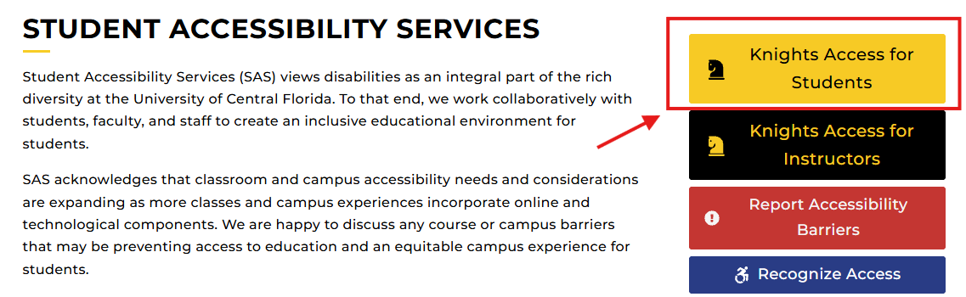
Figure One: Knights Access for Students button on SAS website outlined with a red rectangle around the log-in button labeled "KNIGHTS ACCESS FOR STUDENTS".
2. Contact Your Instructor
- Once your Course Accessibility Letter has been sent, contact your instructor as soon as possible to discuss your AEAA accommodation.
- Together, you and your instructor will develop an AEAA plan for that course.
- Each course requires its own AEAA plan with specific details for how the AEAA will be applied in that course for attendance, missed exams, and missed deadlines due to the medical condition that warrants the AEAA.
- You may use our template to further facilitate this discussion, but it is not required.
3. Finalize Your AEAA Plan
- Your AEAA Plan must be completed before you need to use the accommodation.
- A completed plan needs to be finalized in writing, whether on the SAS AEAA template or via email.
- If you experience difficulty creating a plan with your instructor, contact SAS for assistance.
Reminders for AEAA – Student & Faculty Coordinated Requests
- This process must be completed for each course, every semester that you wish to use AEAA.
- AEAA is not active until your AEAA plan has been completed, agreed upon, and finalized in writing between you and your professor.
- If AEAA is initiated after a course has already begun, any flexibility provided will be based on what is reasonable within the context of the remaining course requirements.
- If you need assistance communicating with your instructor, contact SAS at sas@ucf.edu or 407-823-2371.

General AEAA Usage Reminders & Expectations
- AEAA is not retroactive (meaning it does not apply to absences, assignments, exams, or deadlines that occurred before the accommodation became active).
- A separate AEAA Plan is required for each course where you wish to use AEAA.
- Students who are approved for AEAA must follow the instructions in the Expectations, Guidance, and Reminders for Using Attendance, Exam and Assignment Adjustment (AEAA) Accommodation Effectively document.
- If you have questions or need assistance at any point in the process, contact SAS at sas@ucf.edu or 407-823-2371.

